December 7th, 2008
Hi

As I mentioned last week, last Saturday I went for my first run of the season. By Monday, my legs were very sore! Still, that is no excuse for not doing further exercise. If you just rest until the soreness goes, your level of fitness will also drop. So, on Monday is was 35 minutes on the treadmill again plus some skipping and rowing. On Friday, I had a day off exercise before the run yesterday. Another run of about 2 hours; it felt good but was actually 4 minutes slower than last year. Weather again cool.

A few days ago, there was an interesting astronomical phenomenon visible in some parts of the world. The planets Venus and Jupiter together with the crescent moon were arranged as a ‘smiley face’! (see picture). In parts of the US and Europe it was visible though not as a smile but as a frown!
After breakfast on Friday, I was rather sick. I had to go to the toilet nine times! I also tried to vomit though nothing came out. I do not know what caused it. Food poisoning? But I always thought the effects of food poisoning showed several hours after eating. However, there was no problem during the night after eating dinner on Thursday. And it was too soon for Friday’s breakfast to have any effect.

Also on Friday, China's most recent astronauts arrived in HK for a visit. Big display of the flight in the Science Centre.
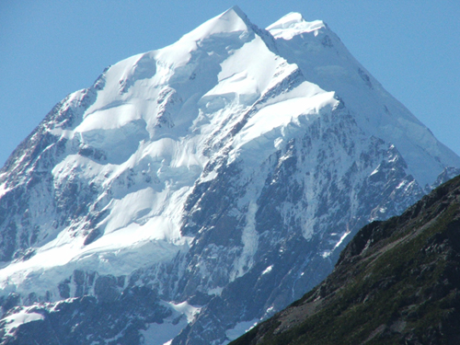
Again, on Friday, two (experienced) Japanese climbers were taken off the peak of Mt Cook after being stranded there for a week due to a storm. One was alive while the other had died just a few hours before the rescue. There have been 150 deaths on Mt Cook since it was first climbed in 1894. (For Mt Everest the figure is something over 200, though I cannot find the current figure.)

The second round of the iRB Sevens tournament was held in South Africa. SA beat NZ in the final.
I have been busy this past week on the Indonesian primary school science course. However, most of the time was spent trying to finalise a syllabus, which is not actually my job.

That’s about it for now.

Cheers

